**Team Name: Team Oasis**

**Chosen theme: Life on Earth**

**Organization name: -**

**Country: Ireland**

**Written by: -**

**Introduction**

The idea for the project was to measure the effects of climate on vegetation density and health. Not only were natural factors investigated but human factors were also investigated such as industrialization, urbanization and war on how plants developed in an area. We are intrigued about how human factors affect vegetation as the more we understand about it the more we can do to combat issues such as Climate change and Global Warming. We expected to discover that plants in areas with large cities or areas with large amounts of industrial development would have less vegetation density and variation and areas with lower development would have higher vegetation density and health.

**Method** – View on [Github[1]](https://github.com/John-116/Astro-Pi-Team-Oasis-2020-2021)

The program we wrote did 2 things :

1. Calculate and log the co-ordinates of the ISS for each image using TLE data from [Celestrak](https://celestrak.com/NORAD/elements/stations.txt) and the [Pyephem](https://pypi.org/project/ephem/) package.
2. Take photos with the **PiNoir camera**. White balance was modified for easier analysis

We calculated how often photos had to be taken by using the sensor Field of view (53.50° +/- 0.13°) and the altitude of the ISS (408km) to make a triangle. The width of a photo was calculated as 410km across (neglecting Earth’s curvature). Assuming the ISS is travelling at 7km/s it would take approximately a minute to travel 400km. We decided to allow for an overlap for processing time and Earth’s curvature for better coverage. To let the program finish roughly 5 minutes early we ran the program every 46 seconds, 226 times.

We used 2 tools to analyze the data.

**Tool 1** - An R script making use of the sf and mapview libraries. The script plots the co-ordinates on a map (Figure 1)

**Tool 2** - [Fiji](https://imagej.net/software/fiji/) which we used to apply an NDVI lut (lookup table) by [cfastie](https://publiclab.org/notes/cfastie/08-26-2014/new-ndvi-colormap) which aided in the analysis of the photos

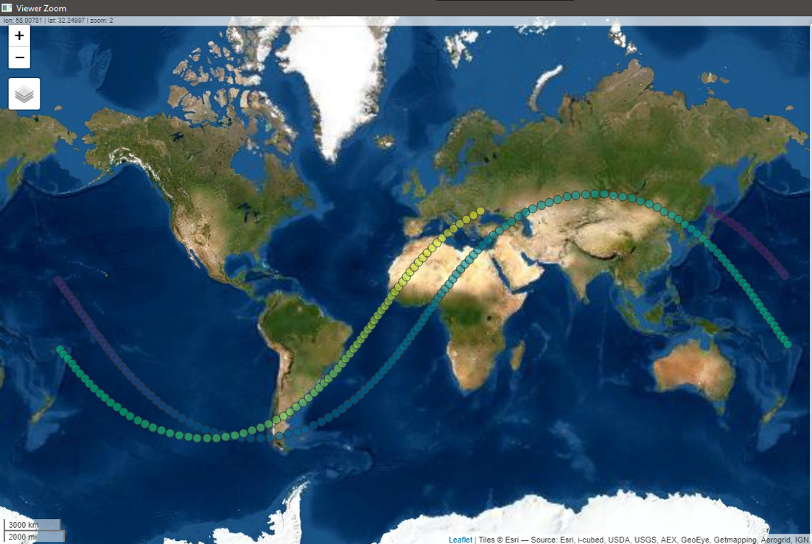

***Figure 1****: Image capture locations*

**Results**

It was decided to focus our studies on Japan as it had the largest number of usable daytime images. We expected to find that the higher population density an area has, the lower vegetation density the area will have due to factors such as urban development and sprawl. We also expected to find that rural areas with less development would have a much higher vegetation density.

We are able to observe the areas with greater vegetation density using a graphical indicator known as **NDVI** or Normalized Difference Vegetation Density. This uses the basic principle that the more photosynthesis that occurs in a plant the more near infrared light it reflects (Figure 2). We can observe this difference using the naked eye and looking at where is greener however it is easier to use software which emphasizes it. In the photos the “hotter” the area the higher the vegetation density and crop health.

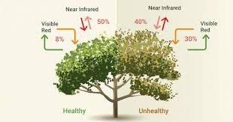

**Figure 2***:* Reflectivity of light for healthy vs unhealthy vegetation

In photo 127 (Figure 3 - Toyama) we see primarily rural areas of Japan. However, in photo 128 we are able to see the large metropolis that is Tokyo, the capital city of Japan (Note that the right side has cloud cover which shows up as vegetation). It is one of the most densely populated areas in the world with roughly 38 million people living in an area of 13,500km². This gives the greater Tokyo area a population density of roughly 2600 people per square kilometer.

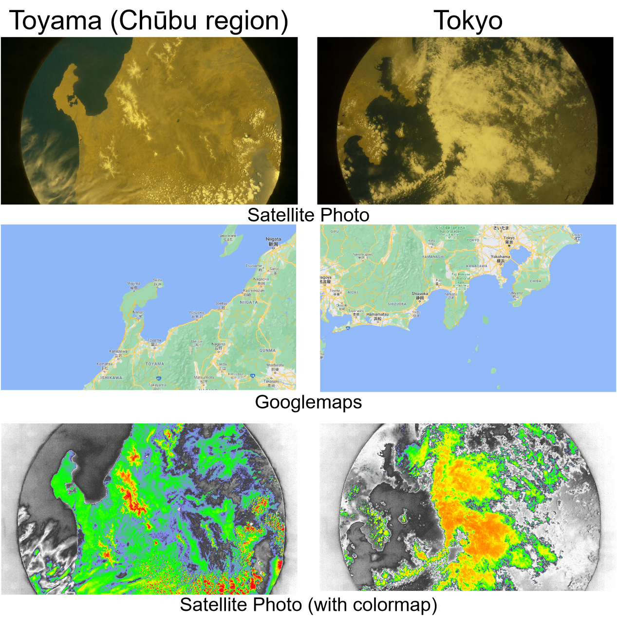

**Figure 3**: Comparison of Toyama and Tokyo using original photos,

Google maps and the satellite photos using a colormap

However, if we look at Toyama we see the eastern coast of Japan and the Chubu region with a population of roughly 21 million people and an area of 67000km² giving it a population density of roughly 300 people per square kilometer. This shows that population density correlates with the lack of vegetation density in an area.

**Conclusions**

We were able to show that urban development is a primary factor in the lack of vegetation in an area by comparing a rural area of Japan and a nearby area which had large amounts of development.

Another take away from this experiment is the importance of sustainable and efficient development as the global population increases. According to the UN the global population is estimated to be as high as [10.5 - 11 billion](https://population.un.org/wpp/Download/Probabilistic/Population/) by the end of the century.

It is critically important that we use our resources efficiently and ensure the use of clean energy and that we keep large vegetation dense areas protected to slow the rates of global warming and Climate Change.

1. Github Repository available at https://github.com/John-116/Astro-Pi-Team-Oasis-2020-2021